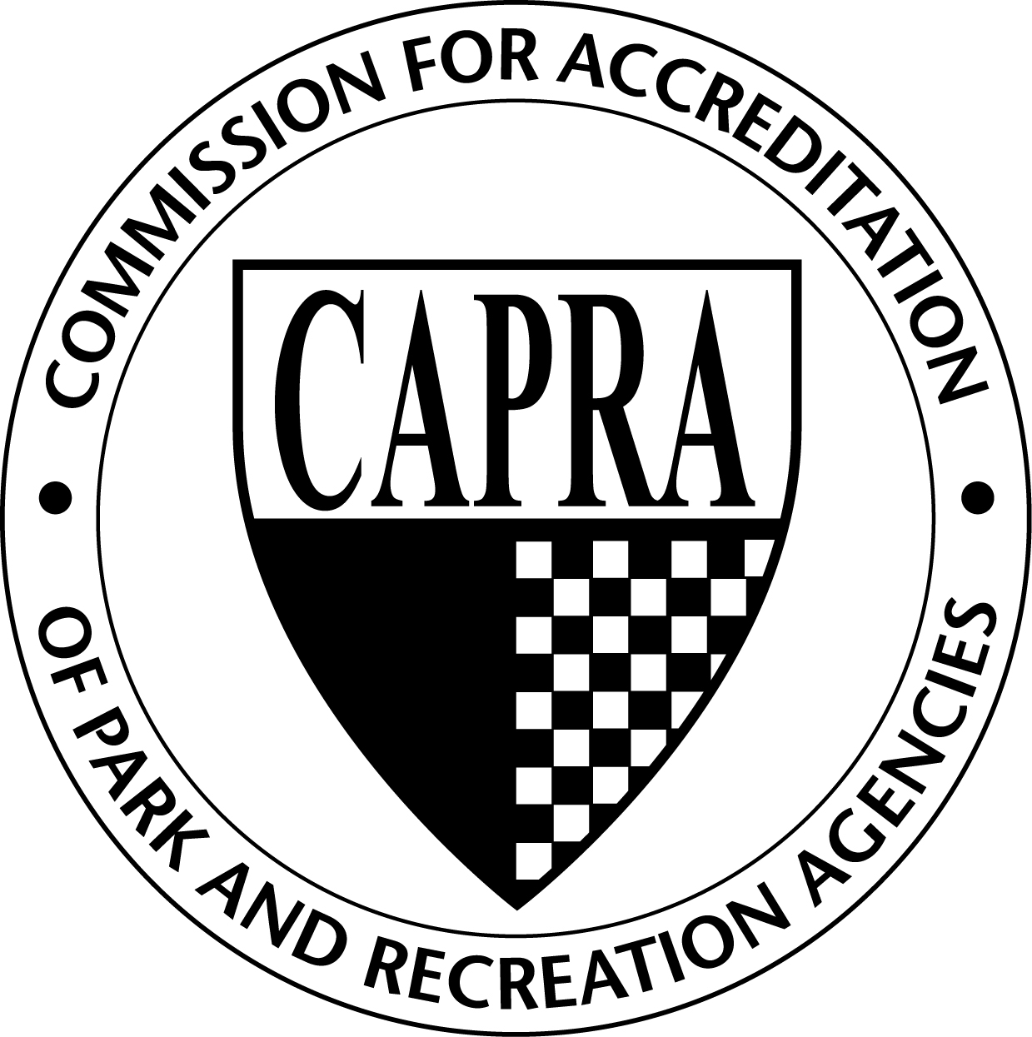
CAPRA Accreditation
Training Request Form

 |  | Date Completed:
Host Organization:
Contact Name: |  |  |  |  |  |  |  |  |  |  | Title:
Address 1:
Address 2:
City: |  |  |  |  |  |  | State: |  |  |  |  |  |  |  |  | Zip:
Phone: |  |  |  |  | Fax: |  |  |  |  |  |  |  |  | Cell:
Email:
Requested Training Date: |  |  |  |  |  |  |  |  | Training Time:
Requested Training Type |  |  | Agency Training Visitor Training Combined Training
Training Location:
Training Fee:
Registration Link:
Signature:

I have read and understand the CAPRA Training Program Hosting Process document and following statement:
- Host organization is responsible for the $800 Hosting Fee plus $5 per registrant, payable to NRPA.
- The number of CAPRA Standards booklets needed must be submitted at least 14 days prior to training.
- Payment for the training must be received within 30 days of training.
- Cancelation fees incurred due to the cancelling of a training by the host are the responsibility of the host.
- Requests to host the CAPRA Training must be approved by NRPA Accreditation Manager.

Office Use Only

Date Form Rcvd: __________ Date Standards Sent: ___________ Date Payment Rcvd: __________

